**Q4 – SQL**

Please refer to the following tables in your database:

Players table:

|  |  |  |  |
| --- | --- | --- | --- |
| PlayerID | PlayerName | Balance | CountryID |
| 1054 | QA_person1 | 10 | IL |
| 2055 | QA_person2 | 20 | GB |
| 3056 | QA_person3 | 55 | IL |
| 4067 | Doron | 70 | US |

PlayersCountries table

|  |  |
| --- | --- |
| CountryID | CountryName |
| IL | Israel |
| GB | Great Britain |
| US | Unites states |

Items table:

|  |  |  |
| --- | --- | --- |
| ItemID | ItemName | Quantity |
| 111 | Ball | 2 |
| 677 | Computer | 54 |
| 123 | iPhone | 8 |

1. Write an SQL query that will return the player name, his country name and balance, for players who live in Unites Stated and their balance is greater than 60:

Answer:

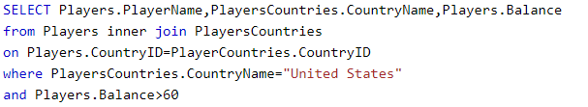

1. Write an SQL query that will summarize the balance for all players who live in Israel:

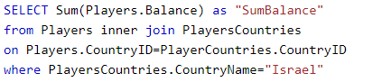

1. Based on the above DB schema, is it possible to retrieve data regarding player purchases (player buy items)?

If yes, write an SQL query that will return all players and their purchased items.

If no, please explain why.

No , impossible to connect Players table to Items table